Supplement to preregistration

1. Gameplay
   1. Participants will be shown a consent screen (instructing them about how the HIT operates and what they will need to complete, along with a consent statement.

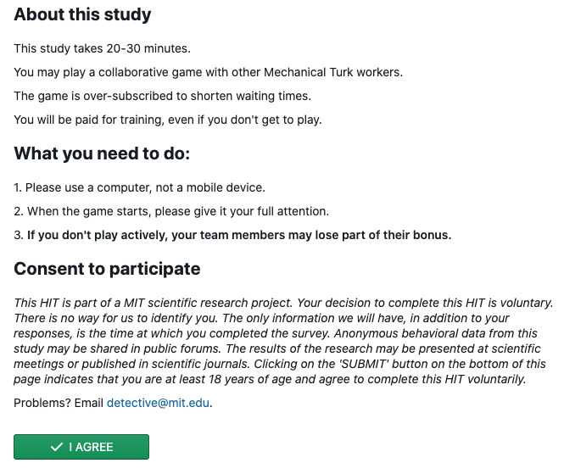

Fig 2. Consent to participate

* 1. The first training screen (Fig. 3) instructs participants in how to interact with the Detective Game interface. They are asked to sort clues into “Promising Leads” and “Dead Ends” by dragging and dropping them into labeled sections of their “Detective’s Notebook”. In addition to the clues each individual is seeded with, they also see which clues two of their collaborators have categorized as “Promising Leads”. Each participant must correctly sort the practice clues before they can continue to the next training screen.

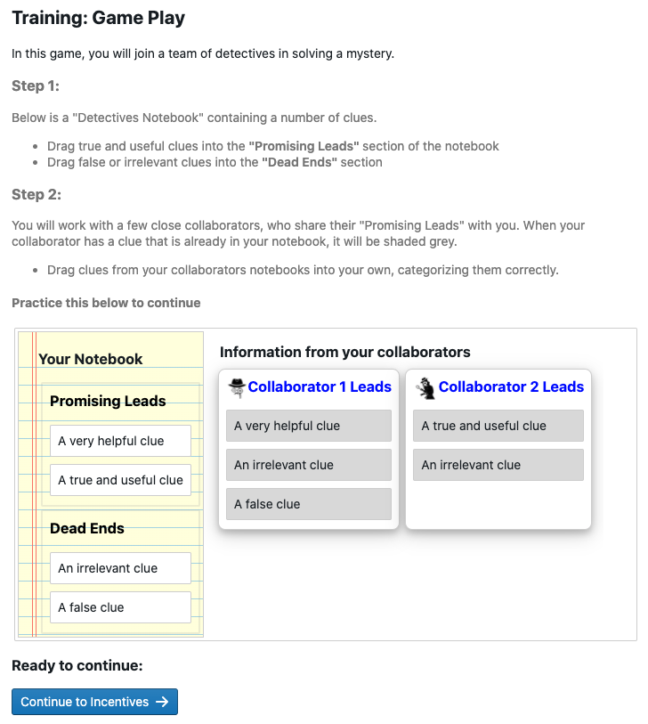

*Fig. 3: Training screen 1 after participant completion*

* 1. The second training screen (Fig. 4) teaches participants how they will be rewarded for their performance. Individuals are told that they will receive $0.10 for each clue correctly categorized as a promising lead, and will be penalized $0.10 for each clue categorized as a promising lead that is actually false. They are also told that they will be rewarded for their team’s average performance, receiving the average of all players’ individual bonuses as a Team Bonus. These incentives encourage individuals to carefully sort clues according to their best estimate of their veracity, and to share clues with their neighbors that they believe will improve the team’s collective sensemaking ability. Setting the reward for success to be equal to the penalty for mistakes works to encourage participants to most accurately assess each statement, rather than ‘hedge’ by keeping too many or too few clues. Participants are compensated $1 for training.

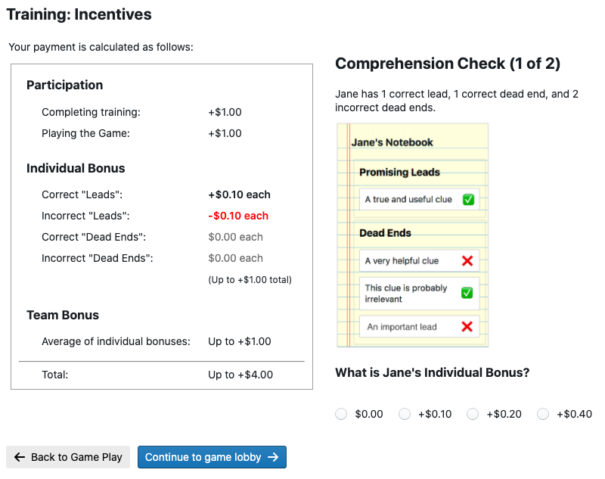

*Fig 4: Training Screen 2 - Incentives (Individual)*

* 1. After completing training (taking between 2 and 4 minutes), participants enter a waiting room until there are 40 individuals who have completed training and are ready to play. The training is oversubscribed so that if some participants are unable to complete the training the game can still launch.
  2. When the game launches, the 40 players are divided into two groups, and assigned to locations in two identical social networks. Each individual is given a “Detective’s Notebook” in which 4 clues start in the “Promising Leads” section. They are also show a “Police Bulletin” (Fig. 5) which gives them background information about the mystery and reminds them of their task. Showing the participant their own clues and the mystery premise before launching them into the game helps them orient to the task.

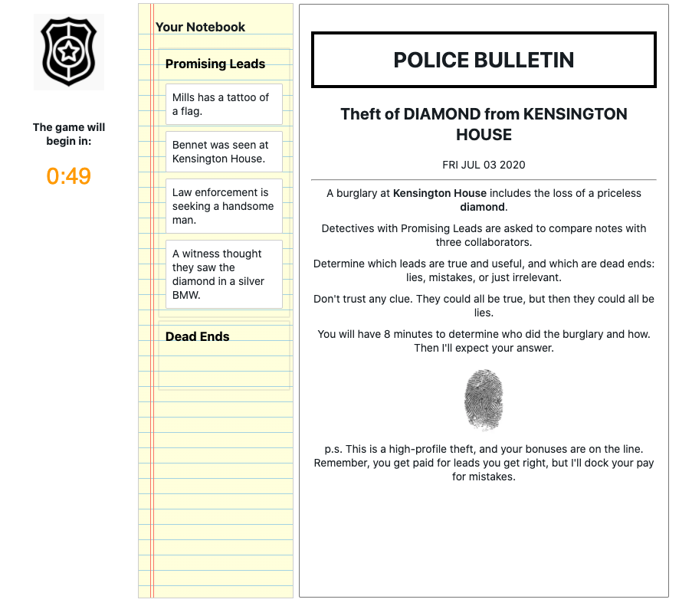

Figure 5: Exposition for the mystery

* 1. When the game launches, the “police bulletin” is replaced with the “Promising Leads” sections of their neighbors’ notebooks, showing the participants 16 unique clues at the start of the game. Individuals at corresponding positions in the two social networks are given clues that are as similar as possible while allowing for the intervention. These are shown for players in the treatment and control conditions in Figs 6a and 6b respectively.

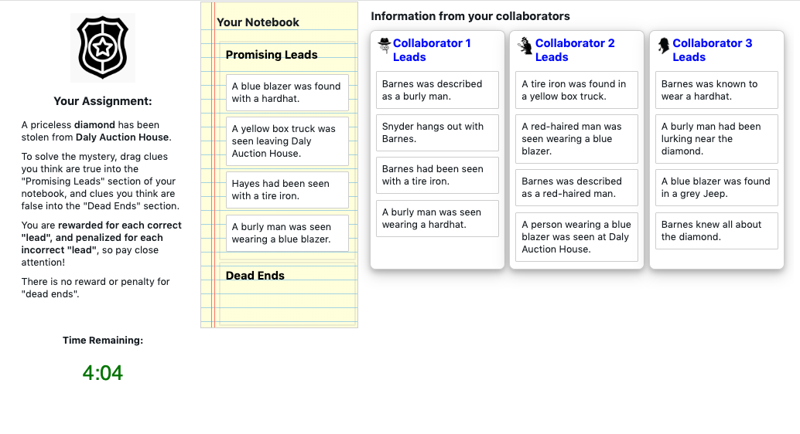

Fig 6a: Game screen – Treatment case

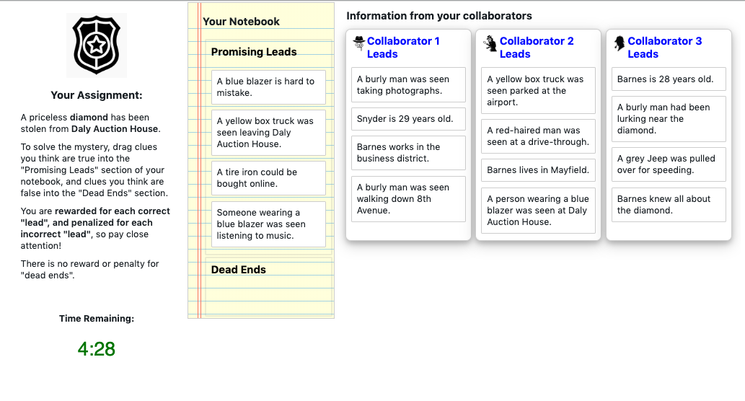

Fig 6b: Game screen – Matching control case

* 1. The game is played in real-time over 8 minutes. When a participant changes their “Promising Leads”, their neighbors immediately see the change on their own screen. The starting clues of every individual are recorded, and every change to every player’s “Detective Notebook” is logged, such that the state of every player’s notebook can be reconstructed at each moment in the game. Participants are compensated $1.00 for playing the game.
  2. Following the game, participants are asked to assess using a slider how likely it is that certain individuals referenced in the game were the burglar, and how likely it is that they used various tools, vehicles, and disguises in the task. The first few of these questions are shown in Fig. 7a. Sliders are labeled from Extremely Unlikely to Extremely Likely, and their positions recorded on a scale from 0 to 100. Participants are also asked to assess their confidence in their solution, and their estimate of the level of consensus among their team, both using similar sliders, as shown in Fig. 7b.

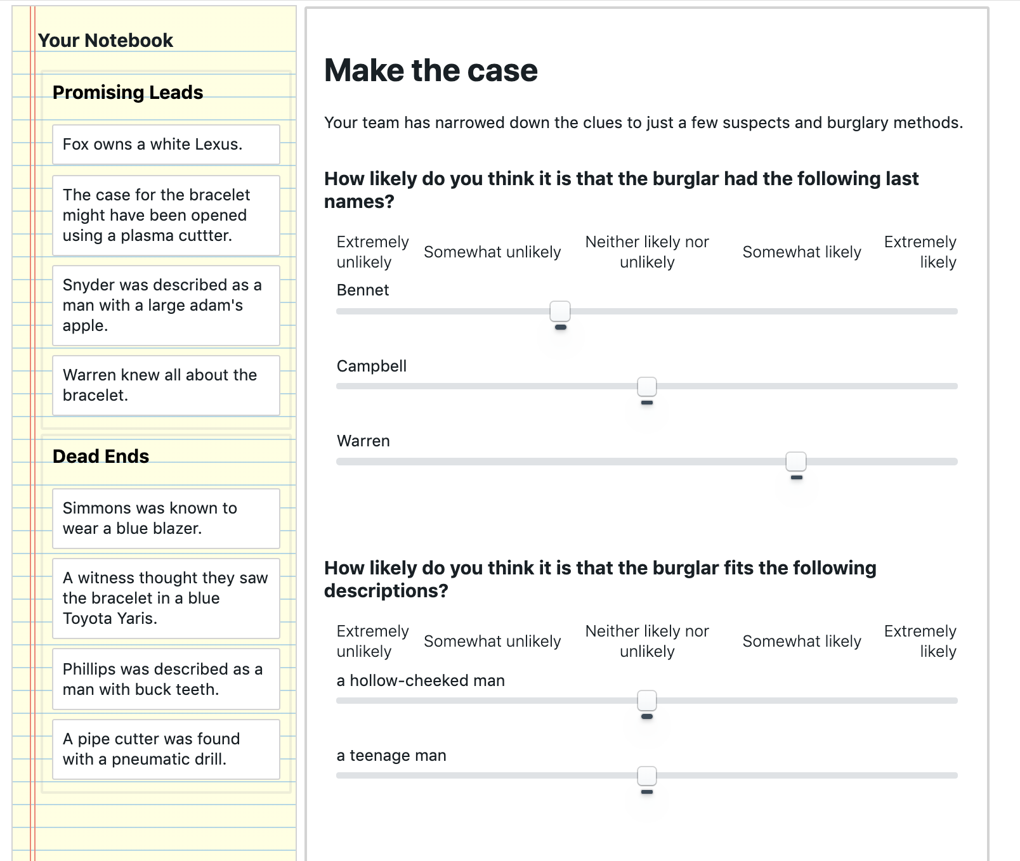

Fig. 7a: Post-game survey screen – Make the case for who committed the burglary

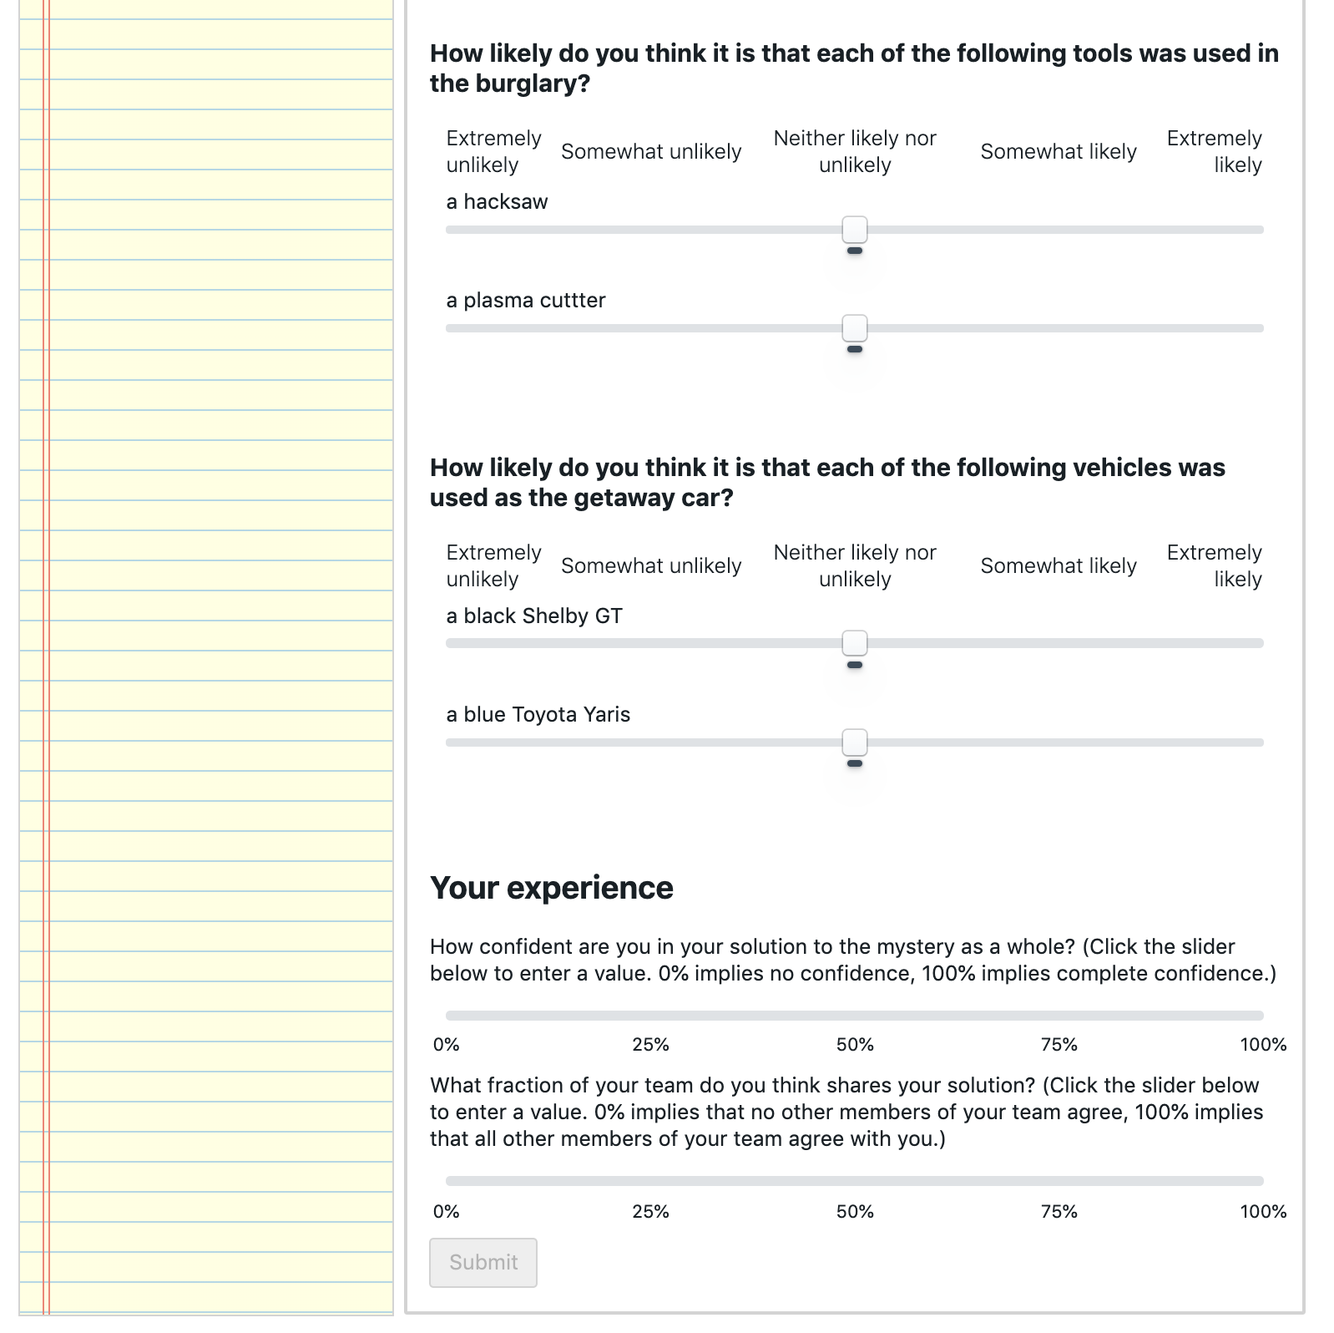

Fig 7b: Post-game survey screen – Assess confidence and consensus

* 1. After “Making the Case”, individuals are told that they were part of an experimental condition in which none of the clues were “False”, and they are rewarded $0.10 for each clue in the “Promising Leads” section of their notebook, along with $0.10 for each of the average number of clues their teammates categorized as a “Promising Lead”. Participants are given a completion code to collect their bonuses, and given an (optional) opportunity to report any problems with the game, and describe their strategy.

1. Manipulation
   1. This experiment manipulates the structure of clues within the mystery game, to create a treatment condition in which the clues interact strongly with each other, and a control condition that limits those interactions while preserving as much similarity with the treatment condition as possible.
   2. Clues are constructed in three waves. The first wave is identical for treatment and control condition, and is illustrated in Fig. 9. Clues are created which link ‘hub’ concepts (including a crime scene and a stolen object) to ‘rim’ concepts (including three suspects, two articles of clothing, two physical descriptions, two tools, and two vehicles). For example “**Hayes** was seen at the **Daly Auction House**” or “The case for **the diamond** might have been opened using **a circular saw**”. A pool of rim concepts was constructed in pre-test to minimize any population bias towards one concept or another. For more details see section 18: *Clue generation procedure*. “Spoke” clues are independent of one another, as they only interact via association with the crime scene and stolen object – items that are known in advance to be relevant to the mystery. There are 11 rim concepts and 2 hub concepts, and so 22 spoke clues.

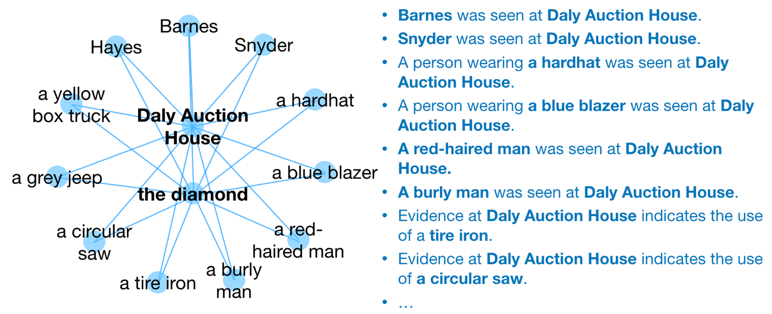

Fig. 9: “Spoke” clues connect rim concepts to hub concepts

* 1. In the treatment case, the second wave of clue construction creates “cross-link” clues, which connect each of the spoke clues to one another (e.g. “**Hayes** owns a **circular saw**”). These cross-link clues create interdependence between the spoke clues, and allow for clues to logically support one another (e.g. if I believe that “A **burly man** was seen at the **Daly Auction House**” and “**Barnes** is a **burly man**”, then I am more receptive to the idea that “**Barnes** was seen at the **Daly Auction House**”). A cross-link clue connects each of the 11 rim concepts to the other rim concepts, for a total of 55 unique cross-link clues, as shown in Fig. 10.

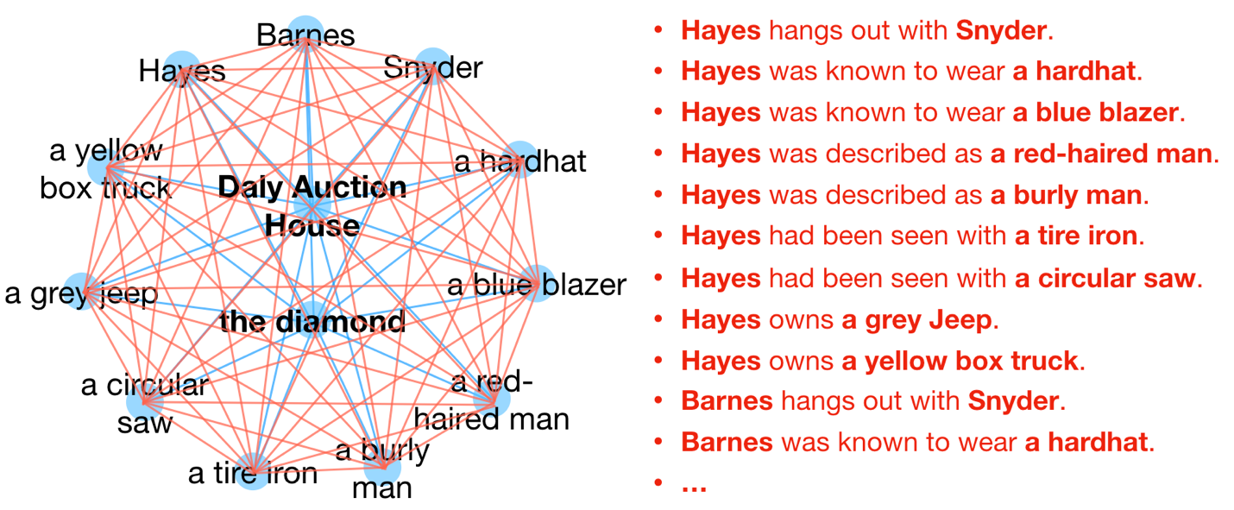

Fig 10. “Cross-Link” clues connect rim concepts to one another

* 1. In the control case, the second wave of clue construction creates “spur” clues that connect to the rim concepts, but do not connect to other clues (Fig 11). There are the same number of ‘spur’ clues in the control case as there are ‘cross-link’ clues in the treatment case: 55. By connecting to the rim concepts (rather than being disconnected altogether) these clues help separate the effect of interdependence manifest as logical relationships between clues from the effect of the frequency of each rim concept in the set of clues. The content of the spur clues was selected in pre-test to have a uniform impact on participants judgement of the rim element to which they connect.

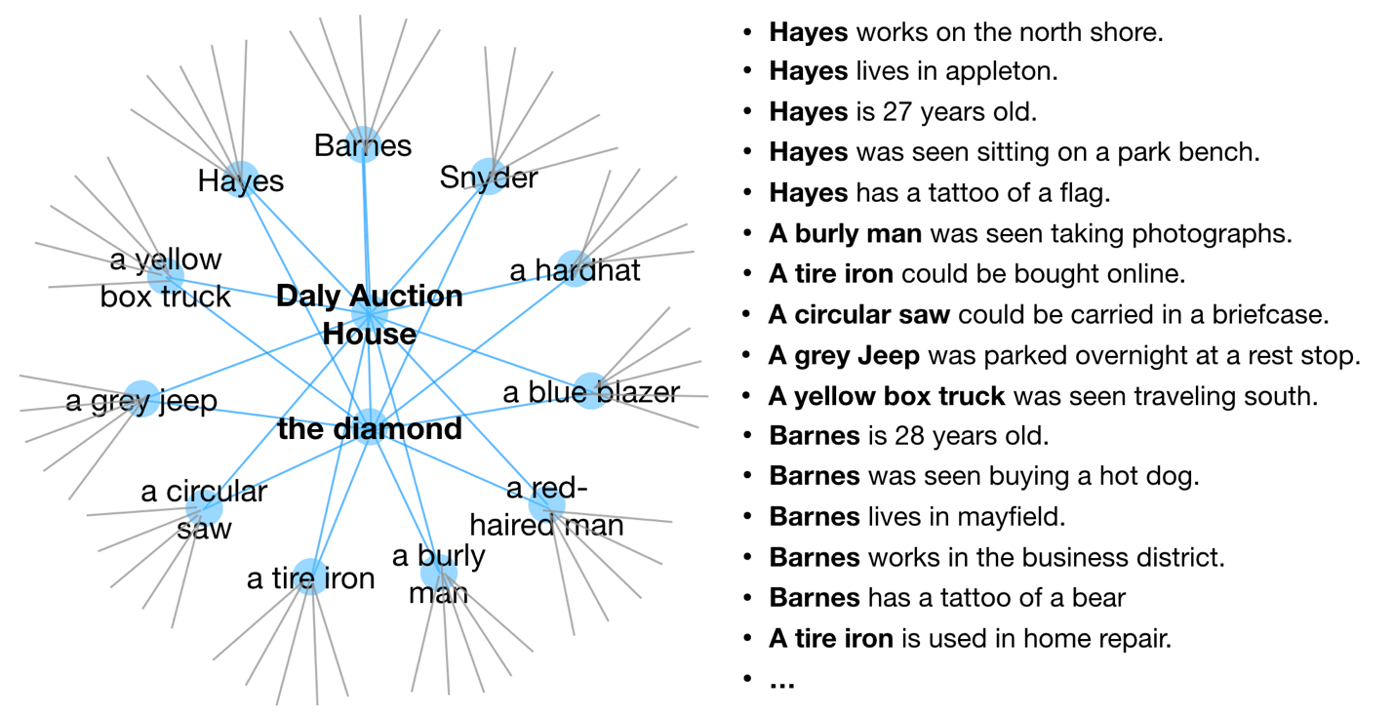

Fig 11: “Spur” clues fill the place of “cross-link” clues without creating links between rim concepts, while still allowing for multiple exposures to rim concepts.

* 1. The first and second waves of clue construction create 77 unique clues. As there are 20 individuals in each treatment within each game, 80 clues are needed to give each individual 4 starting clues. The third wave of clue construction fills the 3 remaining spaces with the clue connecting the crime scene to the stolen object (e.g. The **diamond** was stolen from the **Daly Auction House**.) This is redundant information, as all participants are told this at the start of the game.
  2. Clues are randomly assigned to individuals at the start of the game. Each position in the control world is given the same “spoke” clues as their corresponding position in the treatment world, and a “spur” clue that shares one concept with the “cross-link” clue in the corresponding slot in the treatment game.
  3. The clues to be used in the game, and their assignment to locations in network structures is included in the code supplement to this preregistration.

1. Recruitment
   1. Participants will be recruited from Amazon Mechanical Turk workers residing in the US over 18 years of age. Workers must have completed at least 100 HITs and have a 90% or better approval rating. Recruitment and compensation will be handled using TurkPrime (cloudresearch.com), and the platform will also be used to ensure that workers only participate once.
   2. Between 1 and 2 hours prior to the launch of a game, a “Qualification HIT” will be available to 120 persons, who will be asked to sign up to play by submitting the code “I will show up at <launch time>”. Participants are compensated $0.05 for signing up. (Fig 1)

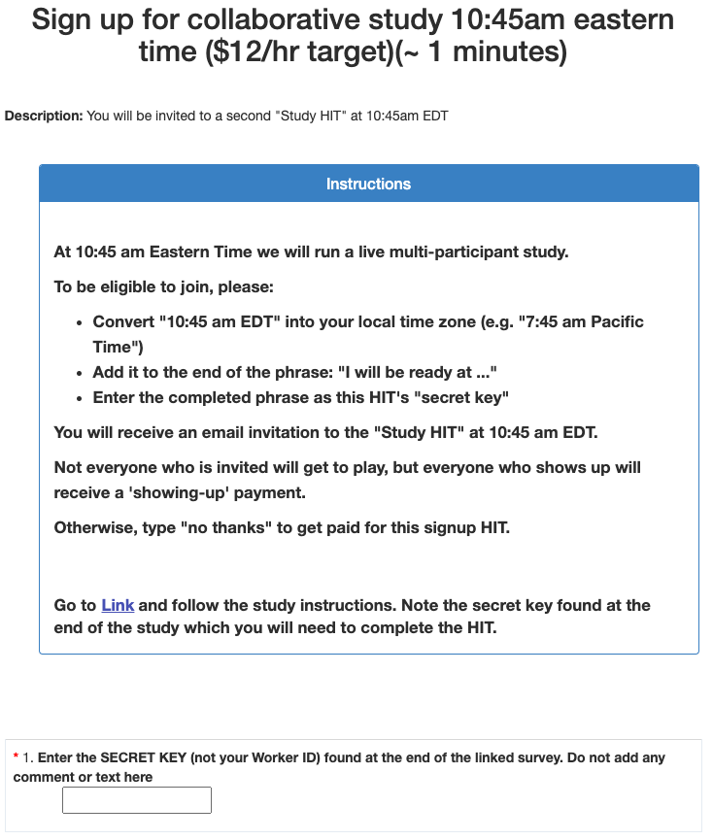

Fig.1 Signup Task

* 1. At the launch time, HITs will be made available to all who signed up to play, and these individuals will receive an automated email instructing them to proceed to the game. Participants are compensated $0.10 for showing up at the launch time. Pilot tests indicate that the recruitment strategy has about 75% yield.
  2. The game takes about 20 minutes to play, including training, waiting room, and follow-up. The average payout is approximately $4.00, for an hourly rate of approximately $12.00/hr. Participants who train but are unable to play take about 5 minutes before they are bumped, and earn $1.10, for an approximate hourly rate of $13.20. Fig. 8 shows the number of participants active in different parts of the game at different times for one pilot test.

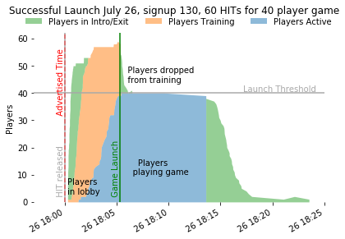

Fig. 8: Active players by stage

1. Clue generation procedure (Pretest)
   1. Clues are constructed from a bank of concepts (11 Stolen Objects, 11 Crime Scenes, 33 Names, 22 descriptions, 22 articles of clothing, 22 tools, and 22 vehicles) and set of relationships (e.g. {Name} owns a {vehicle}, {A witness thought they saw {stolen object} in {vehicle}) that forms a complete network between all concepts. These are randomly shuffled such that different clues can be generated for each game.
   2. The bank of concepts was constructed by starting with a pool of candidate concepts approximately 3-4x the size of concepts eventually used. A pretest survey was conducted in which Amazon Mechanical Turk workers were asked to assess how likely a number of concepts was to have been used in a generic burglary. Individuals saw a subset of the concepts and were asked to give their gut reactions using a slider from Extremely Unlikely to Extremely Likely, as illustrated in Fig 10 below. In total, 139 participants rated each of 403 candidate concepts between 20 and 30 times. Participants in the pretest were paid $1.25 for a task which took each participant an average of about 4 minutes.

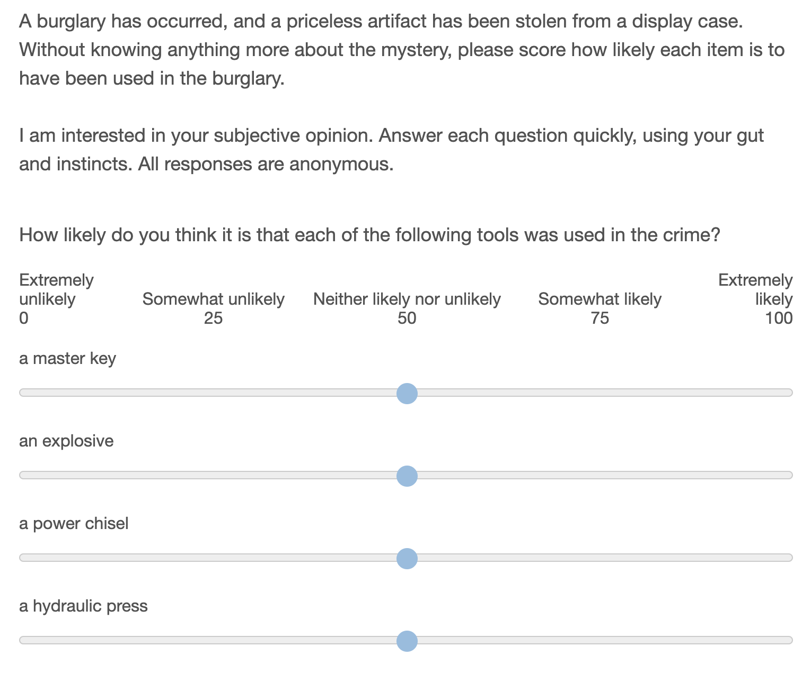

Fig 10: Pretest the perceived likelihood of each item being used in a crime

* 1. The pool of candidate names in the pretest represents the subset of the 200 most popular last names in the United States with a racial composition of between 50% and 80% ‘White’, as recorded in the 2000 US census. This selection is made to minimize the possibility of racial biases in the results. Additionally, names which are also common first names are excluded (e.g. “Stewart” or “Ross”) as are names which also serve as descriptors or adjectives in other clues (e.g. “Green”, “White”, or “Young”).
  2. The remaining candidate concepts were written such that they would be as independent from one another as possible (e.g. I do not include both “a fat man” and “an overweight man” as these are synonymous, nor both “an old man” and “a man with grey hair” as these are perceived to go together.)
  3. From the pretest results, I selected a subset of concepts that are perceived to be as likely as one another to be used in a burglary. (This helps to ensure that we do not see games in which all participants adopt “a set of lock picks” as a tool in the burglary, and reject “a machette”, just because lock picks are easier to imagine being used in a burglary.) The final selection was made by taking the subset of beliefs that minimized the difference in mean value of pretest survey responses when responses are normalized for each individual, and cross-checking against the means of the raw responses. 11 concepts were selected for each time the concept (name, vehicle, etc.) is used in a game.
  4. A similar pretest survey was conducted to select ‘spur’ clue concepts from a pool of candidates.

1. Display considerations
   1. Presentation of social information**:** All at once display
      1. A ‘scrolling feed’ type information display has recency and primacy effects, and opens questions about how we should aggregate social information from multiple players. Showing all information at once, in the order that it is sorted by the neighbor, eliminates the effect of alternate ordering sequences.
   2. Number of neighbors**:** 3
      1. The number of neighbors is limited by the size of the screen and an individual’s ability to process information. The minimum number of neighbors for a non-trivial social network is 3, and is also a reasonable number for managing the cognitive load in the game.
   3. Number of starting clues**:** 4
      1. Fewer starting clues are preferred for minimizing cognitive load on individuals. With three neighbors, individuals see 16 clues all at once when they start playing. This takes about 30 seconds to read through and understand. The next increment (5 starting clues) gives 20 items for an individual to process at game start, which starts to be cognitively overwhelming.
   4. Number of players**:** 20
      1. Larger numbers of players are better for generalizability and seeing an effect size. Smaller numbers mean we can afford more replications. There needs to be enough players that the mean shortest-path-length is greater than two, to realistically represent multi-stage diffusion.
   5. Network shape**:** Dodecahedron and regular connected caveman (k=5)
      1. Eleven symmetric candidate networks were evaluated with n=20 and degree=3. Of this set, the Dodecahedral network minimizes the average shortest path between individuals with no network clustering, and represents a social network we should expect to exhibit low polarization *a priori*. A regular connected caveman network maximizes the characteristic path length and exhibits strong clustering, and so we expect to exhibit more polarization *a priori.* Descriptions of each of these networks are included in the preregistration code.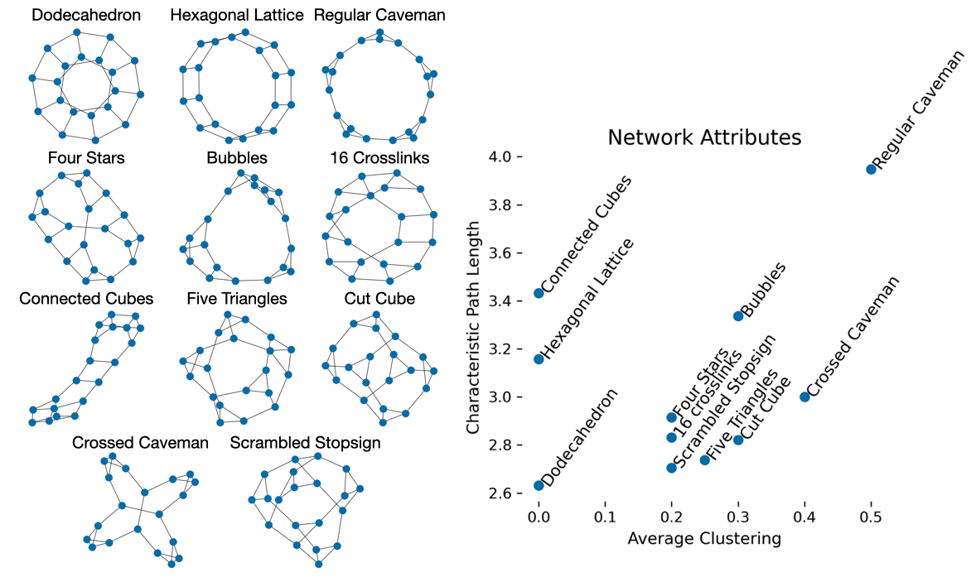
   6. Number of unique clues in the game**:** 78
      1. From an information diversity perspective, more clues is better. With 4 starting clues and 20 players, we can have up to 80 unique clues in the game. 13 nodes yields 78 clues, and the two spots remaining can be filled with the given link between the crime scene and the stolen object.
   7. Number of times each clue is represented: 1*
      1. Each clue should be represented an equal number of times so as not to bias the network to one particular outcome.
      2. *The ‘given’ clue that the object was stolen from the crime scene is included 3 times to fill out the 80 slots in the game.
   8. Length of game: 8 minutes
      1. Pilot trials were conducted with durations of 5 and 8 minutes. It was observed that participants remained engaged for 8 minutes, and felt rushed with 5.
   9. Survey format: Empty sliders
      1. Rather than force individuals to make a discrete choice between suspects/vehicles etc., a slider allows individuals to assess a degree of confidence in their assessment of the solution to the mystery.
2. Choice of Measures
   1. Self-report similarity: Pearson Correlation
      1. Correlation is a natural measure when we have a fixed number of continuous measures of each subject, as is the case in the self-report, and there is precedence for this use in recent literature *(4)*. It is useful to have a measure with a fixed range (-1,1) and which is readily interpretable.
   2. Behavioral similarity: Phi coefficient
      1. The phi coefficient corresponds to Pearson correlation when measures are binary, and has the same interpretable (-1,1) range. This is appropriate for a universe in which there are a finite number of beliefs measured, but would be less appropriate as the number of adopted beliefs becomes a very small fraction of the total number of possible beliefs.
      2. Other measures of similarity are present
   3. Polarization
      1. Percent of Variance present in first principal component
         1. This measure corresponds to the notion of “constraint” articulated by Dimaggio et al. *(6)*. In their paper they describe Chronbach’s alpha and the PCA measure both providing similar measures of constraint. I have chosen the PCA measure here as more interpretable and well known among computational social scientists.
      2. 5TH and 95th percentile similarities
         1. There are a number of different measures in the literature that try to capture the notion that with polarization, the most similar individuals become more self-similar, and the least similar individuals move further away from one another. The fact that no single measure has emerged as the leader hints at problems with each. Variance *(see 1,6)* captures heterogeneity between individuals, but not clustering into camps. Kurtosis *(see 1,6)* is predicated on a bimodal distribution. The “gap” statistic *(4)* is one of dozens of ways of assessing the quality of a machine learning clustering algorithm. When the identities of camps are already known the difference of means between groups can be used *(6,7).*
         2. As I do not need to identify the groups themselves, or compare to external datasets, it is sufficient for me to merely report what each of these other measures is trying to approximate: the similarity that is found within groups, and that which is found across groups. As I am only interested in the relative differences between conditions (or for the same population over time) then I can arbitrarily designate a threshold for which comparisons will be considered ‘within-group’ or ‘across groups’. This provides a much more intuitive demonstration of increasing polarization than the measures found in literature.
         3. The closer the chosen thresholds are to the tails of the distribution, the more conservative the claim that the comparisons beyond this threshold are appropriately “within” or “across” groups. At the same time, we need enough samples included in the set to minimize noise due to the finite number of comparisons. In this 20-participant social network, the 95th and 5th percentiles correspond to 10 comparisons between individuals.